Alarm: ID 57: Flexi Module Status
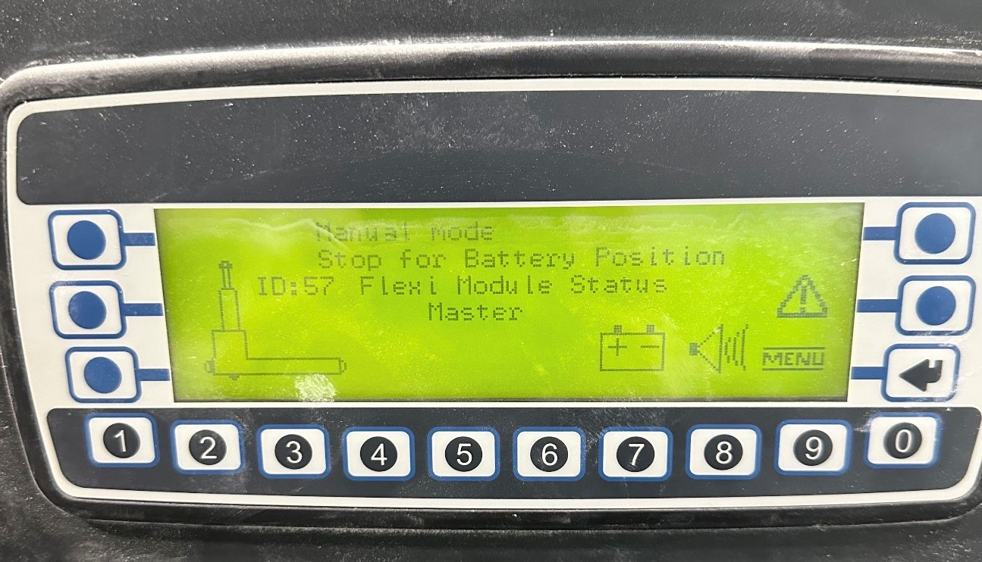
How To Fix:
This alarm occurs when switching from Automatic to Manual mode fails.
To resolve:
- Return to the desired mode and try the switch again.
- If the issue persists, try replacing the remote with a new one.
- If the problem continues, contact a qualified AGV Technician.

